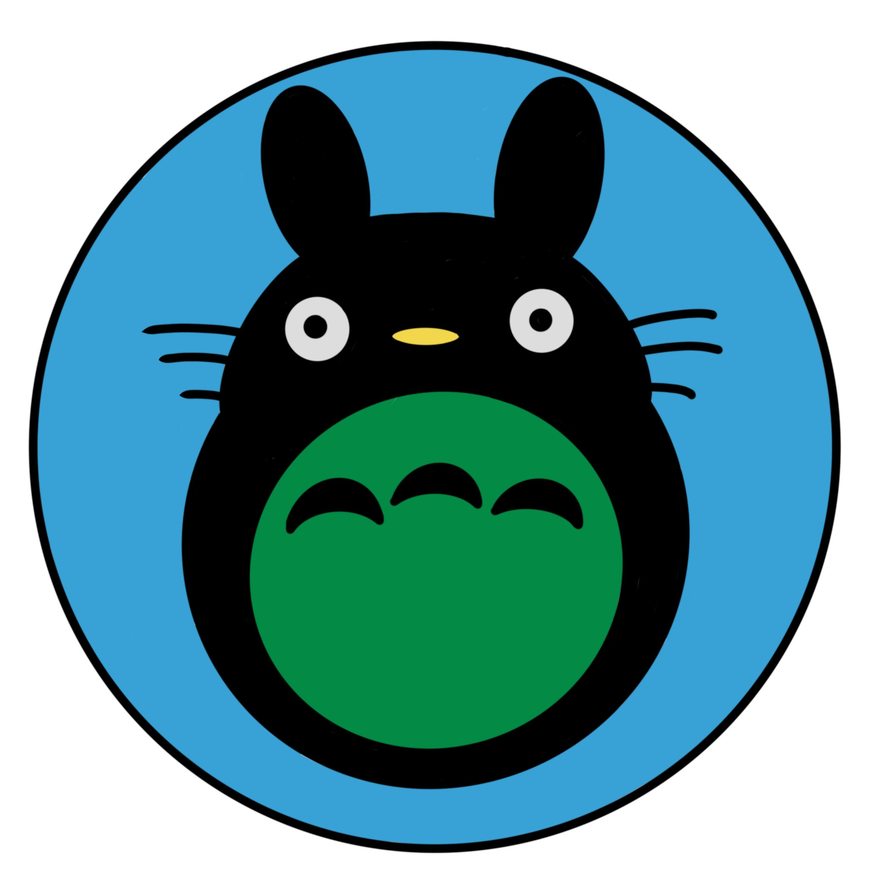**Studio Ghibli Museum**

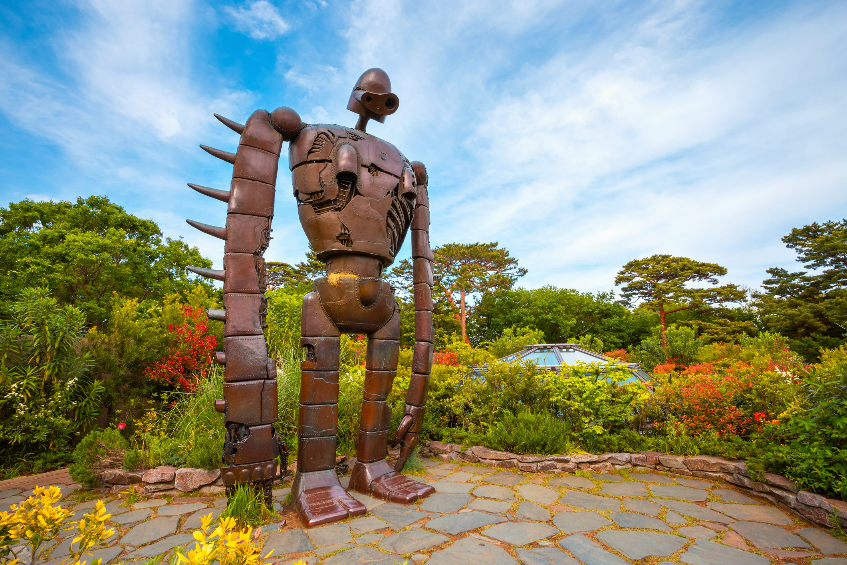\

Information

The Studio Ghibli Museum offers a whimsical experience filled with interactive exhibits, original artwork, and an overall sense of wonder for every visitor. Exploring the museum usually includes themed rooms, short exclusive films, and a rooftop garden featuring iconic characters. Creating this magical world requires careful design and a limited number of guests inside at one time. We can help you understand everything the museum features before you visit.

The museum provides a guided flow through its spaces by sharing its years of creative history through structured displays. You can explore hand-drawn sketches or special installations that change with each season. Customized visits are more memorable than rushing through. Experiences may include the Saturn Theater, the Catbus room, the Straw Hat Café, and the rooftop Laputan robot. To enter, you must purchase tickets online in advance, as no tickets are sold at the museum itself.

Price List

|  |  |
| --- | --- |
| **Age** | **Cost** |
| Adult | 1000 円/$7 |
| 13-18 | 700 円/$5 |
| 7-12 | 400 円/$3 |
| 4-11 | 100 円/$1 |

3 and under Free